Roman Shaikh

Student number: 18300989

CS7DS3-Applied Statistical Modelling

Short-Assignment-2

# Question 1:

Suppose $y$ follows a Poisson distribution so that $y \sim (θ)$ and

$P\left(Y=y\right)=\frac{1}{y!}θ^{y}exp⁡(-θ)$

1. General Exponential family of distribution form is given by:

$$P\left(x \right| η)=h\left(x\right)exp⁡(η^{T} t\left(x\right)-a\left(η\right))$$

Where $η$ is called “**natural parameter**”

$t(x)$ is called “**sufficient static**”

$h(x)$ is called “**underlying measure**”

$a\left(η\right)$ is called “**log normalizer**”

Given, $P\left(Y=y\right)=\frac{1}{y!}\exp\left(-θ\right)θ^{y}$

$$=\frac{1}{y!} exp⁡(y\log{θ-θ)}$$

Therefore, on comparing above equation with standard form, we get

$$a\left(η\right)=θ$$

$$η^{T}=\log{θ}$$

$$h\left(x\right)=\frac{1}{y!}$$

$$t\left(x\right)=y$$

When we have enough samples / observations $y_{i} i=1…n$, this PDF becomes as follows,

$P\left(\frac{y}{θ}\right)= \prod_{i=1}^{n}{\frac{1}{y_{i}!}\exp\left(-θ\right)θ^{y_{i}}}$

$=\frac{1}{\prod_{i=1}^{n}{y_{i}! }}\exp\left( -nθ\right) θ^{∑y_{i}}$

$=\frac{1}{\prod_{i=1}^{n}{y_{i}! }}\exp{(∑y_{i}log θ-nθ)}$

Here, $η\left(θ\right)=\log{θ}$ is **Natural parameter.($ϕ(θ)$)**

$a\left(θ\right)=\exp\left( -nθ\right)$ is the **link function / log normalizer**. **($g(θ)$)**

$h\left(y\right)=\frac{1}{\prod_{i=1}^{n}{y_{i}! }}$ Is **the normalizing constant. ($h(y)$)**

$t\left(x\right)=∑y_{i}$ is the **sufficient static. ($s(y)$)**

1. We build a Poisson regressing model using

$$\log\left(y\right)=α+βX+ε$$

Here $y$ is a count Response variable.

We can also consider y/t (i.e. the incident / response), where $t$ is the time interval or space or grouping.

$X$ is the exploratory variable.

Therefore, we consider $y/t$ as our outcome.

We require, the No. of times a customer defaults a loan - ? | Given some variables.

For this, We first group customers based on defaulter count.

We consider variables like the annual income & No. of Loans of a customer.

We can group this variable in different brackets like:

* **Annual income {**Low income (0 to 30k), High income ( 30 to 50k)}
* **No. of Loans** {<2, 2-5, >5}

The customers with same values of feature variable $X_{1}, X_{2}…X_{n}$ belong to same group. i.e. defaulter or not defaulter.

E.g. 0 – No defaulter & 1 - Yes defaulter.

|  |  |  |
| --- | --- | --- |
| Total Loan | Income group | Defaulter status |
| <2 | High | 0 |
| 3-5 | Low | 1 |
| >5 | Low | 1 |
| >5 | High | 0 |
| <2 | Low | 0 |
| … | … | … |

Therefor as from above example we can identify a defaulting customer based on the No. Of loans and the income group.

**Effects on analysis:**

Interpretation of parameter estimates

$$\log\left(μ\right)=α+βX$$

$$μ=\exp\left( α+βX\right)$$

$$=\exp\left(α\right)\exp\left(βX\right)$$

1. When $β=0$, we get $\exp\left(α\right)=μ$ i.e. mean of $μ$ [ expected count of y is $e^{α}$]. This implies X is not related to y
2. If $β>0$, then $\exp\left(β\right)>1$ and expected count $E\left(y | x\right)$ is $\exp\left(β\right)$ times larger than when $X=0$
3. Similarly, if $β<0$, then $\exp\left(β\right)<1$ and expected count $E\left(y | x\right)$ is $\exp\left(β\right)$ times smaller than when $X=0$

If the time t is not considered, then we can apply linear regression instead of Poisson.

# Question 2:



Latent Variable:

$α$ = Parameter of the Dirichlet prior on the pre-document topic distribution

$β$ = Dirichlet prior on the pre-topic word distribution.

$y_{i}$ = topic distribution of document i

$z_{ij}$ = topic of word j in document i

Parameters:

$w_{ij}$ = specific word

**Latent Dirichlet allocation (LDA):**

* LDA is a generative model in statics which allows set of observed values to be explained by unobserved groups.
* LDA is an example of topic model, widely used in NLP for classifying words in a document and identifying topics.

The PDF of Dirichlet distribution is given by

$Dir\left(θ \right|α )=\frac{1}{β\left(α\right)} \prod_{i=1}^{K}{θ_{i}^{α_{i}-1}}$, where $β\left(α\right)=\frac{\prod_{i=1}^{k}{τ\left(α_{i}\right)}}{τ(\sum_{i=1}^{k}{α_{i})}}$ and $α=(α_{1}…α_{k})$

**Graph for Latent Dirichlet allocation (LDA):**

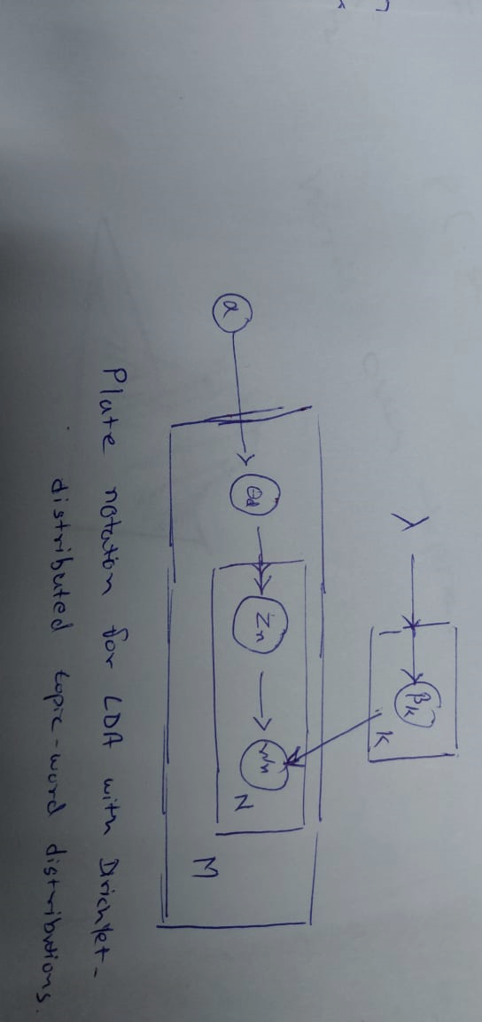

*Plate notation for LDA with Dirichlet-distributed topic-word distributions*

Explanation:

1. First, we draw multinomial distribution for each topic $y_{i}…y_{k}$
2. Then for each document we generate a multinomial distribution $y_{i}\sim D \left(α\right)$
3. Follow this by selecting for each work a multinomial distribution parametrized by Y

Below we find the visualization of Dirichlet distribution with varying :

🡪 We suppose uniform mean across m = $\frac{1}{k},$ equal probability distribution for all multinomial distribution.

🡪 If $α$ is increased to a larger value, this concentrates the probability distribution around mean i.e. in center of the simplex.

🡪 If mean m is different and $α$ is adjusted, then the mean can be concentrated around three corners

🡪 when m = no. of topic concentrated around edges with very less probability, to belong to any of the topics.

**Mixture model:**

* Mixture model is a probabilistic approach for representing the normally distributed subpopulations within an overall population.
* They generally don’t require knowing which subpopulation a data point belongs to , allowing the model to learn the subpopulation automatically.

**One-dimensional Model is given by:**

$$p\left(x\right)= \sum_{i=1}^{K}{ϕ_{i}N\left(x | μ_{i}, σ_{i}\right)}$$

$$N\left(x\right|μ_{i}, σ_{i})=\frac{1}{σ_{i}\sqrt{2π}}exp\left(-\frac{{\left(x-μ_{i}\right)}^{2}}{2σ_{i}^{2}}\right)$$

$$\sum_{i=1}^{K}{ϕ_{i}=1}$$

**Graph for Mixture Model (Non-Bayesian GMM):**

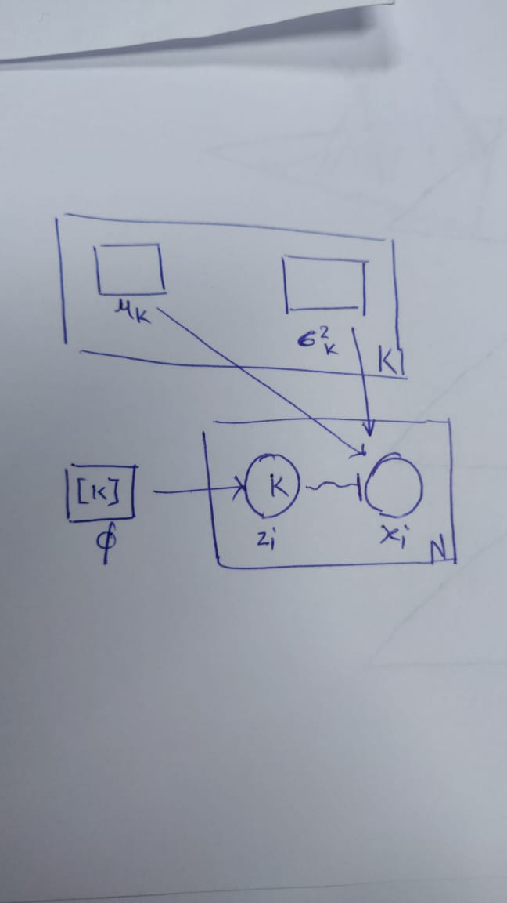 Where,

K 🡪 Number of mixture components

N 🡪 number of observations

🡪 component of observation i

🡪 observation i

🡪

🡪 mean component of i

*Non-Bayesian Gaussian mixture model using plate notation.* 🡪 Variance component of i

🡪

**Differences between these two models:**

**LDA:**

* LDA is not a purely mixture model but a **admixture** model.
* Has more than one latent variable.
* Used to model documents and topics
* For each topic we calculate the Multinomial distribution

**Mixture Model:**

* Mixture models can be either Gaussian mixture model, multivariate gaussian mixture model OR a categorical mixture model
* MMs use single latent variable
* This are modeled over number of observations.
* There are two main parts in a mixture model a kernel with parameter $θ$ represented by $P\left(α \right|θ)$ and a mixing distribution $P(θ)$